**R.I.C.E. Treatment for Acute Musculoskeletal Injury**

Self-Care to Reduce Pain and Swelling With Soft Tissue Injuries

By [Carol Eustice](https://www.verywellhealth.com/carol-eustice-187896)

Updated on November 06, 2023

 Medically reviewed by [Mohamad Hassan, PT](https://www.verywellhealth.com/mohamad-hassan-pt-dpt-5072151)

Table of Contents

View All

* [Rest](https://www.verywellhealth.com/what-is-rice-190446#toc-rest)
* [Ice](https://www.verywellhealth.com/what-is-rice-190446#toc-ice)
* [Compression](https://www.verywellhealth.com/what-is-rice-190446#toc-compression)
* [Elevation](https://www.verywellhealth.com/what-is-rice-190446#toc-elevation)
* [Other Treatments](https://www.verywellhealth.com/what-is-rice-190446#toc-is-the-rice-treatment-still-recommended)

R.I.C.E. stands for rest, ice, compression, and elevation. It is a method of self-care to use right after you experience a minor injury.

R.I.C.E. is used to quickly treat pain and swelling after an acute (sudden) [soft tissue injury](https://www.verywellhealth.com/first-aid-4014723) such as a sprain or strain, or a joint dislocation.12

However, the R.I.C.E. method may be outdated, which will be explored in this article, along with explaining how to manage each step of the R.I.C.E. method and when it's important to seek medical help.

0 seconds of 1 minute, 18 secondsVolume 90%

1:18

**How to Treat a Sports Injury with R.I.C.E. Technique**

R.I.C.E. should be started as soon as you notice pain and swelling in the injured area. Here are the basics of R.I.C.E.

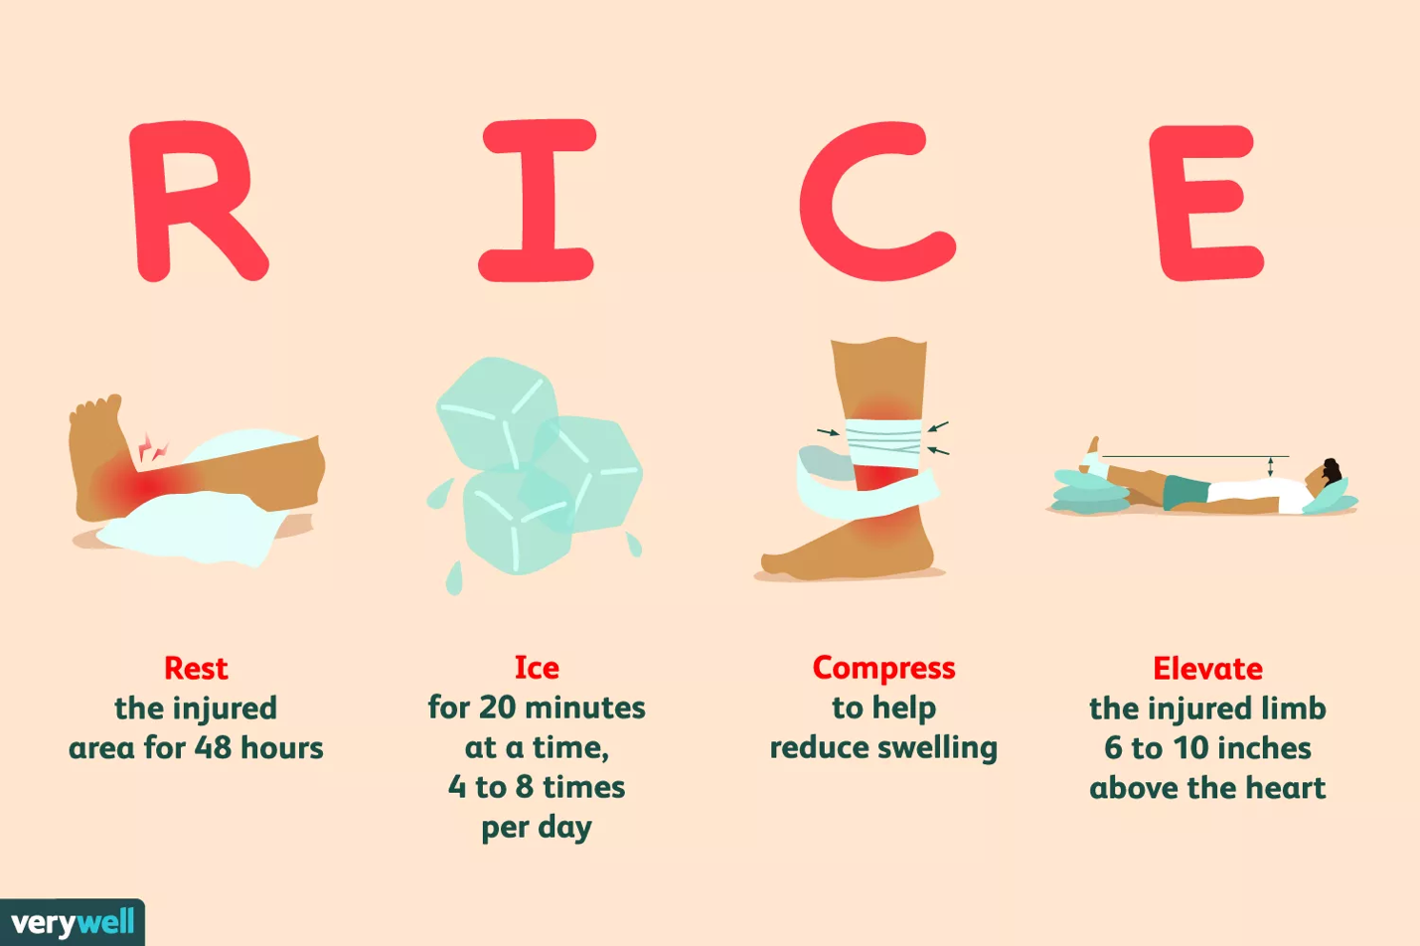

Verywell / JR Bee

Rest

Rest may prevent further injury and speed up the healing of injured tissue.3 Without rest, movement and weight bearing can continue to aggravate an injury and cause increased [inflammation](https://www.verywellhealth.com/signs-of-inflammation-4580526) and swelling.

It's best to rest the injured area for 48 hours, if possible, or at least avoid putting unnecessary stress on it. If you have a leg injury, you may need to stay off it completely and not bear any weight on it. Assistive devices or [mobility aids](https://www.verywellhealth.com/mobility-aids-what-you-need-to-know-189387) (such as a cane or a sling) may be helpful for reducing pressure on an injured joint or limb.4

Ice

Ice is useful for reducing pain and inflammation associated with an acute injury. Icing is believed to be most effective if done during the first few hours after the injury has occurred. You can apply ice for 20 minutes at a time and as frequently as every hour.4

Use a cold gel pack or a plastic bag filled with ice, but do not apply a bag of ice directly to the skin. Instead, wrap the bag of ice in a towel or another material to keep the ice from directly touching your skin. Often, gel packs or cold packs sold for this purpose have a cover provided.

Avoid leaving an ice pack on on your injury for more than 20 minutes at a time. This can damage the skin or lead to an [ice burn](https://www.verywellhealth.com/frostbite-with-an-ice-pack-1298334).

After you remove the ice pack, give your skin time enough to get warm before icing it again.

Compression

Compression of an injured or painful ankle, knee, or wrist helps to reduce the swelling.4 Elastic bandages, such as ACE wraps, are usually effective. Special boots, air casts, and splints can offer both compression and support. Your healthcare provider can suggest the best option for you.

Do not apply a compression bandage too tightly, as this can interfere with your blood circulation. If you feel throbbing, the bandage is probably wrapped too tightly; take it off and put it back on more loosely.

[Elastic Bandage Dos and Don'ts](https://www.verywellhealth.com/elastic-bandages-1298333)

Elevation

Elevate the injured part of the body above heart level.4 This provides a downward path for draining fluid back to the heart, which may reduce swelling and pain. Try to elevate the entire limb 6 to 10 inches above the heart. You can lie down and use a pillow to help elevate the injured limb.

[How to Treat a Pulled Muscle](https://www.verywellhealth.com/how-to-treat-a-pulled-muscle-2549859)

Is the R.I.C.E. Treatment Still Recommended?

Although the R.I.C.E. method has been used for decades for musculoskeletal injuries, recent studies suggest that it may not be the most effective approach.5

In fact, some researchers argue that R.I.C.E. may even be harmful and delay the healing process because it restricts blood flow to the injury, which is essential for the healing process.6

Other treatment protocols that have been suggested include P.E.A.C.E., L.O.V.E., and M.E.A.T.

P.E.A.C.E. Protocol

The P.E.A.C.E protocol is recommended for short-term (acute) care of an injury. The acronym stands for:7

* **Protect:** Minimize movement for about one to three days.
* **Elevate:** Keep the limb above the heart to promote fluid (edema) flowing out of the tissues. Note there is weak evidence supporting the use of elevation, but there are no risks, so it is often still used.
* **Avoid anti-inflammatories:** The various phases of inflammation help repair damaged soft tissues. So, inhibiting inflammation using medications may negatively affect long-term tissue healing, especially when higher dosages of anti-inflammatory medications are used.5
* **Compression:**Taping or bandaging may help limit fluid accumulation (swelling) and tissue bleeding.
* **Education:** Healthcare providers should educate patients about the benefits of an active approach to recovery. Passive modalities (such as electrotherapy, manual therapy, and acupuncture) early after injury have insignificant effects on pain and function compared with an active approach.5 They may even be counterproductive in the long term.7

L.O.V.E. Protocol

After the first few days, it is thought that a musculoskeletal injury needs a different approach, such as the L.O.V.E. protocol. This acronym stands for:7

* **Load:** Putting body weight on the injured area should be added early and normal activities resumed as soon as symptoms allow, without worsening pain.
* **Optimism:**Beliefs and emotions are an important part of the healing process. Psychological factors such as [catastrophizing](https://www.verywellhealth.com/managing-anxiety-and-catastrophic-thinking-5192375), depression, and fear can be barriers to recovery.
* **Vascularization:** Pain-free aerobic exercise should be started a few days after injury to boost motivation and increase blood flow to the injured structures.
* **Exercise:** Exercise helps restore balance, mobility, and strength early after injury and helps reduce the risk of recurrent injuries.5

M.E.A.T. Protocol

Like the L.O.V.E. protocol, the M.E.A.T. protocol is centered around active care and implementing movement as soon as possible.8

M.E.A.T. increases the flow of blood to injured areas in order to enhance the healing process. Soft tissue structures such as ligaments, tendons, and cartilage don’t get a lot of blood supply to begin with, so this protocol tries to maximize blood flow to the injured area.

The acronym stands for:8

**Movement:**Puts a small amount of load on the ligament, which helps new tissue to grow and removes fluid and blood. The movement needs to be gentle and not worsen pain.

**Exercise:** Once the pain level has decreased and movement of the injured area increases, exercise is added to further increase circulation, adding fresh blood and removing debris from the damaged tissue.

**Analgesia:** Pain limits one’s ability to efficiently move the injured area through a full range of motion. Instead of using non-steroidal anti-inflammatories (NSAIDs) which may delay the recovery process, try Tylenol (follow the dosage recommendations on the label) or herbal remedies to manage pain.

**Treatment:** Implementing a variety of therapeutic approaches, such as kinesiology taping, [acupuncture](https://www.verywellhealth.com/acupuncture-for-pain-relief-7369616), [soft tissue release](https://www.verywellhealth.com/joint-mobilization-5215349), and/or [transcutaneous electrical nerve stimulation (TENS)](https://www.verywellhealth.com/what-is-tens-and-how-does-it-work-2564548) may be beneficial as the healing progresses.

Keep in mind that every injury is different and requires a personalized strategy recommended by a trained healthcare professional.

When to Seek Medical Treatment

Many common acute injuries can be helped by one of the recommended protocols, especially when combined with over-the-counter pain relievers. However, if your pain and swelling don't begin to go down after 48 hours, you should see your healthcare provider.

Get professional treatment immediately if any injury is severe. A severe injury implies that there is an [obvious fracture](https://www.verywellhealth.com/gallery-of-fracture-pictures-4020369), dislocation of a joint, prolonged swelling, or prolonged or severe pain. Serious injuries may require more intensive treatment and possibly surgery.

[How a Stress Fracture in the Foot Feels](https://www.verywellhealth.com/stress-fracture-in-foot-7975298)

Summary

With an acute injury, it's important to bring pain, swelling, and inflammation under control as soon as possible. The R.I.C.E. method and P.E.A.C.E. protocol are simple ways to do this on your own at home in the short term. You may want to include an ice pack and an ACE bandage in your first-aid kit in case you need them at some point.

If you are still experiencing pain and swelling after 48 hours of R.I.C.E., contact your healthcare provider.

**Frequently Asked Questions**

* What’s better for a sudden sprain: ice or heat?

Traditionally, ice is recommended for the first 48 hours or so, because it reduces inflammation and swelling (due to increased blood flow to the area), and pain. However, some researchers discourage ice, arguing that the extra blood flow could allow the body to heal itself more quickly.9 You can try ice or no ice, depending on what seems to work for your recovery, but never use heat on a new acute injury.

Learn More [How to Correctly Ice an Injury](https://www.verywellhealth.com/how-long-should-you-ice-an-injury-2696108)

* How do you use compression to treat an injury?

Compression means wrapping an injured area of the body with an elastic bandage to reduce swelling. You need to wrap it in a way that provides light pressure. Don’t wrap it so tight that you feel numbness, tingling, more pain, or additional swelling. A compression wrap should only be needed for the first 48 to 72 hours after an injury.10

Learn More [When to Use Compression Bandages](https://www.verywellhealth.com/elastic-bandages-1298333)

* How long do I need to rest following an injury?

It depends on the extent of the injury and other factors, but at least two to three days of rest are usually recommended. However, you may not want to keep the injured area totally immobile. Talk to your healthcare provider about whether you should do some light exercises or movements to prevent stiffening and pain.11

Learn More [How to Treat an Injured Knee](https://www.verywellhealth.com/how-to-wrap-your-knee-5112816)